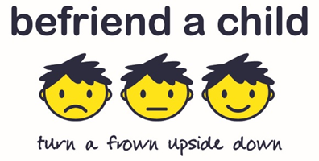
Befriend a Child Youth Club Registration Form
To be completed by the Parent/Carer
Child’s Name | Date of Birth

Parent/Carer Name | Mobile Number

Address:
Postcode | E mail Address

Has the child any medical conditions | YES | NO
If yes, please state

Is the child on any medication> | YES | NO

If yes, please state

Has the child any allergies? | YES | NO

If yes, please state

Emergency Contact Details
Name
Relation to the child
Mobile Number

Photographic Consent:
There may be times when photographs will be taken at Youth Club and consent is required from parent/carers to do so. Please tick the relevant box below
Befriend a Child publicity material,

Website and social media,

I do not wish photographs to be taken of my child at any time.

Befriend a Child Youth Club
Guidelines for Parent/Carers

Befriend a Child aim to always keep children safe during the club and the following guidance is in place.

- Children must be dropped off and picked up by a parent/carer.
- Children will be always supervised by the Youth Club Leader and volunteers.
- The Youth Club leader is first aid trained. All volunteers and the Youth Club Leader are PVG checked.
- All children are covered by Befriend a Child Public Liability Insurance.

Please sign below and return the form to info@befriendachild.org.uk

Signed
Date

